Lecture 1

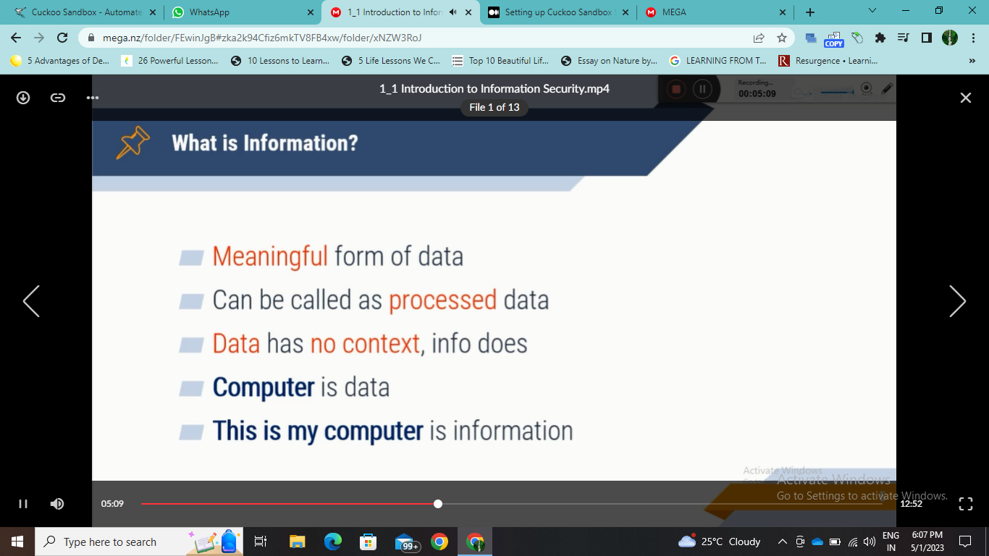

Data is jumbled anything is data but any useful data is information

Birthday is on 20 May -🡪 data

My birthday is on 20 May -🡪 information

Data is the unprocessed and raw facts and figures

Information are the processed form of data

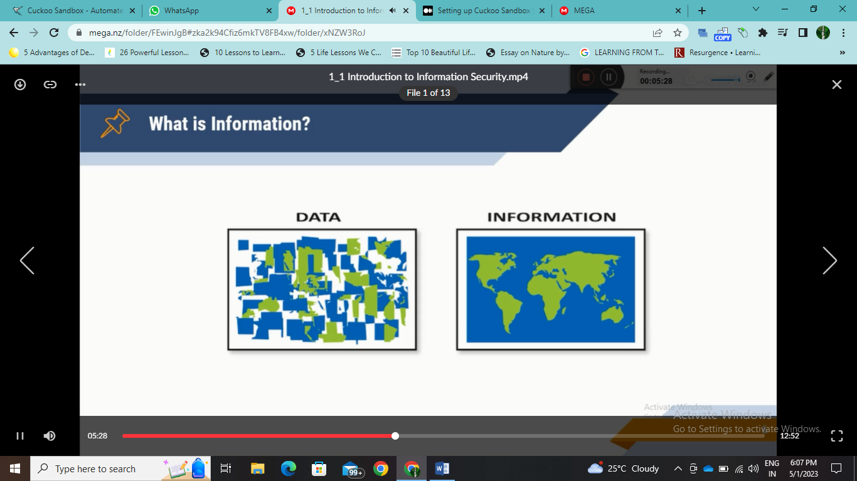

Info sec?

Data vs. information?

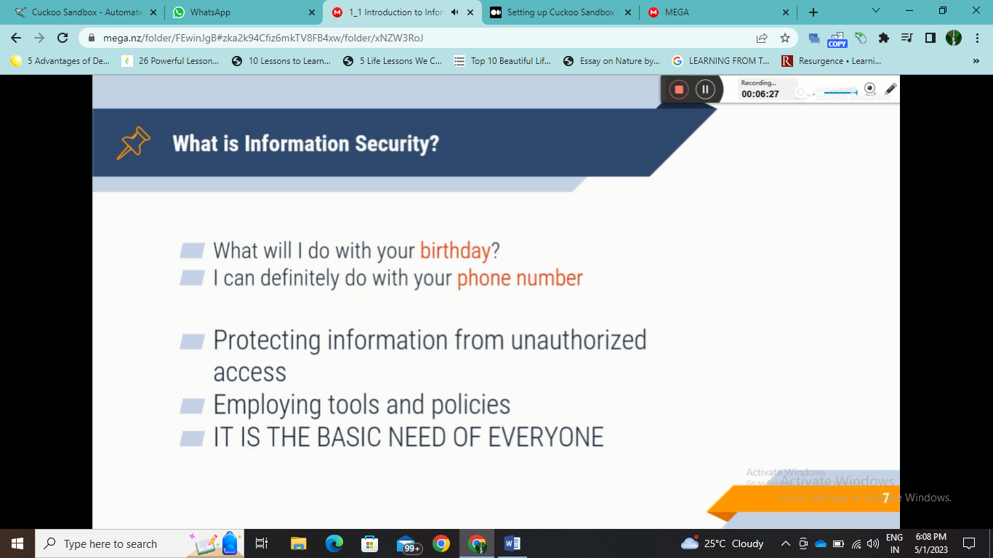

Information security is a need of everyone we should protect our info from third parties….example NSA and our government have access to the search history of the internet

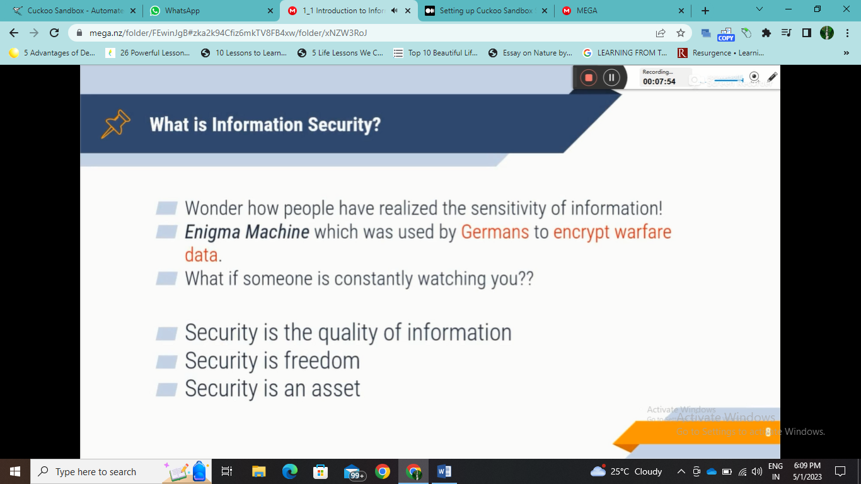

**A very old information security machine with many router machines is an electromagnetic machine.**

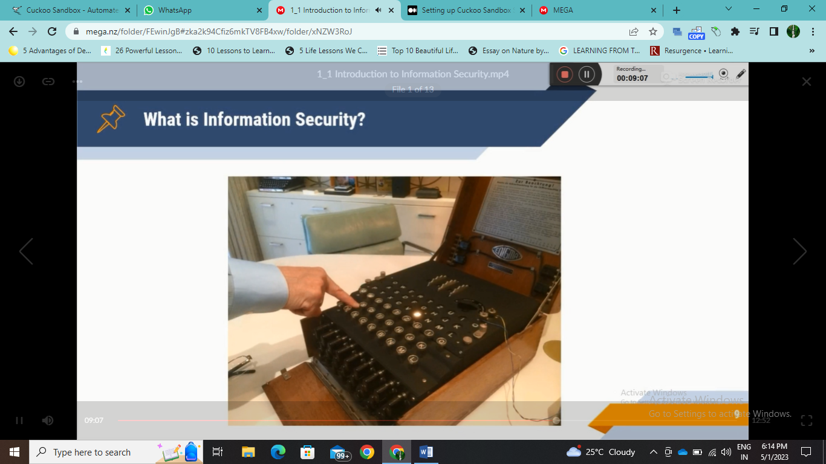

**Photo is here and this is an enigma machine every time we press any key any random key light up this happens as of routers and gears … to provide the info secretly in secret codes …**

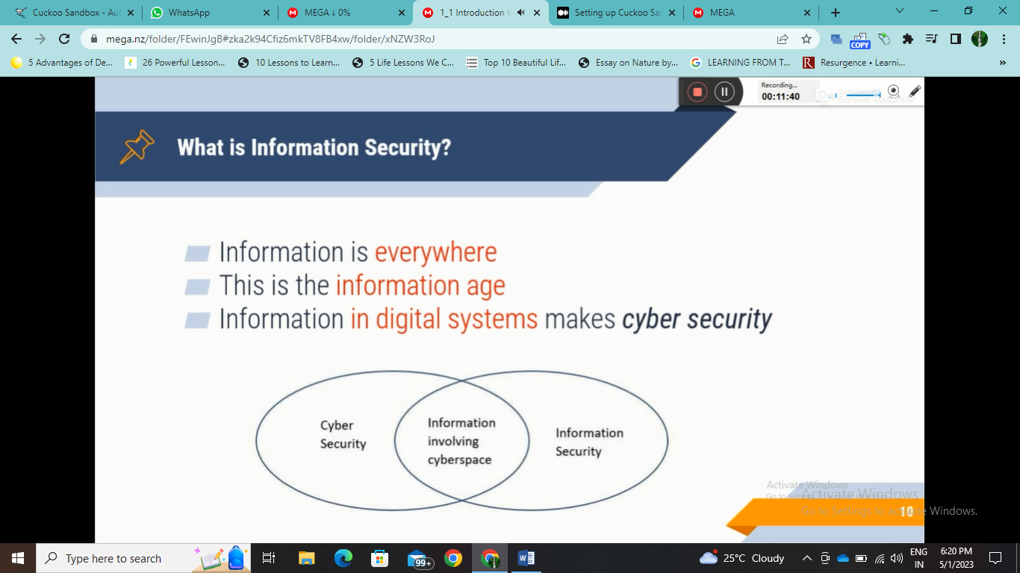

**Any information stored digitally in cyberspace is cyber security.**

**Lecture 2**

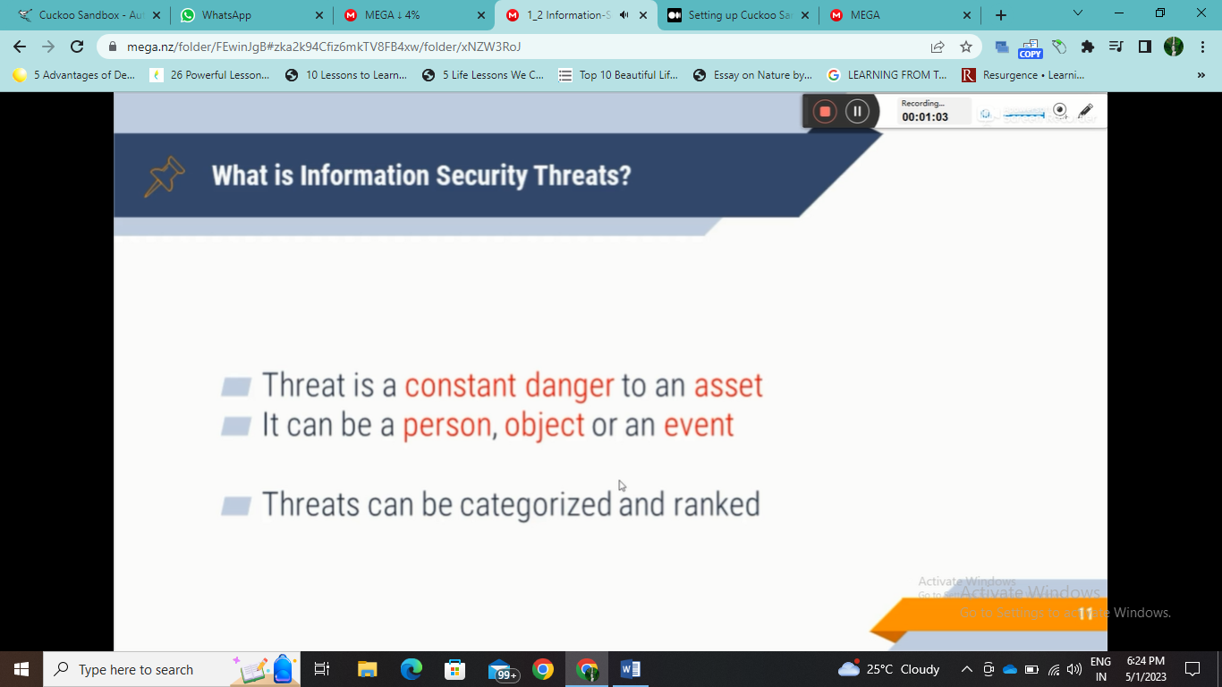

**Like you have pizza and your chota brother wants to eat it so your brother will be a threat to pizza**

**So threat can be anyone any person or any object (like public Wi-Fi router) or any event like (data breach)**

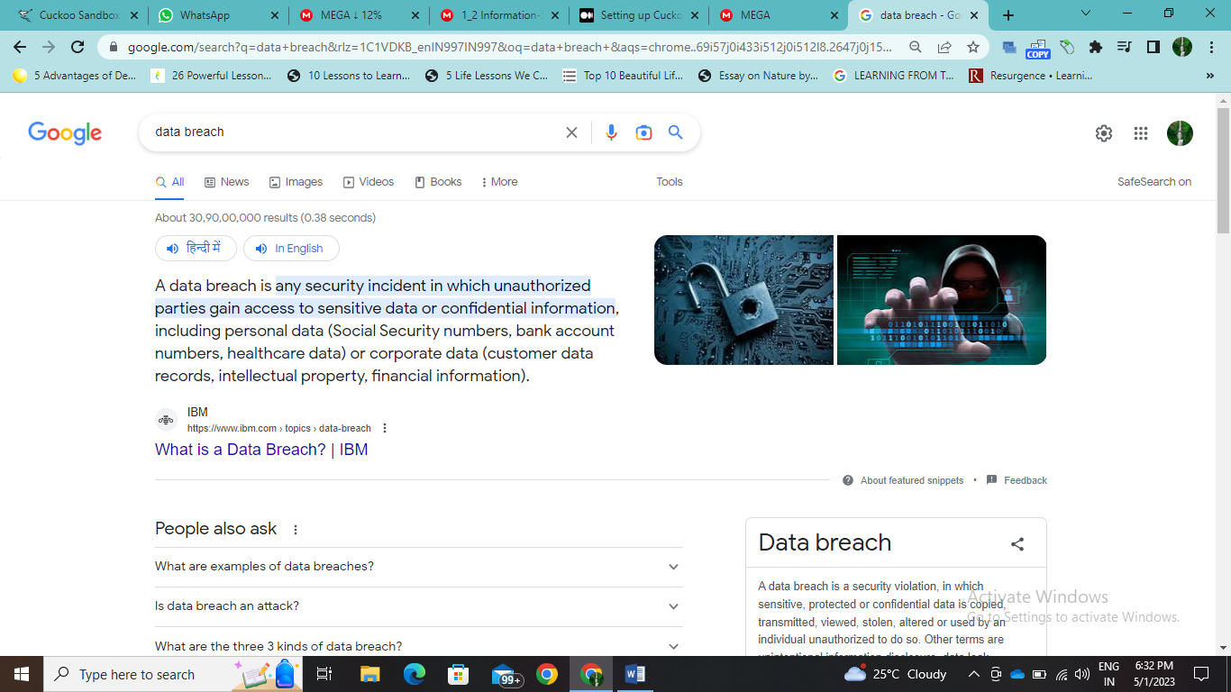

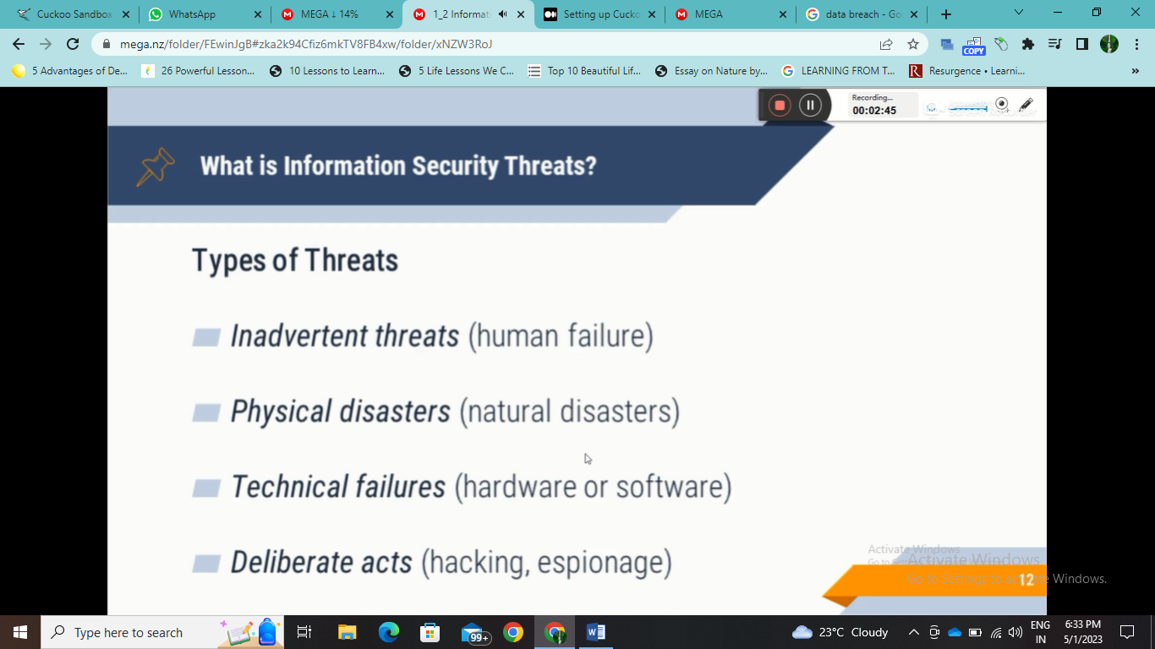

**Inadvertent threats are threats that are caused by humans not intentionally like saving karna bol Gaye or backup Lena bhul Gaye**

**Physical disasters like data center disasters or workstation**

**Technical failures like CPU breakdowns or hard disk crashes or software hung**

**Deliberate acts like hacking and espionage done intentionally**

**Lecture 3**

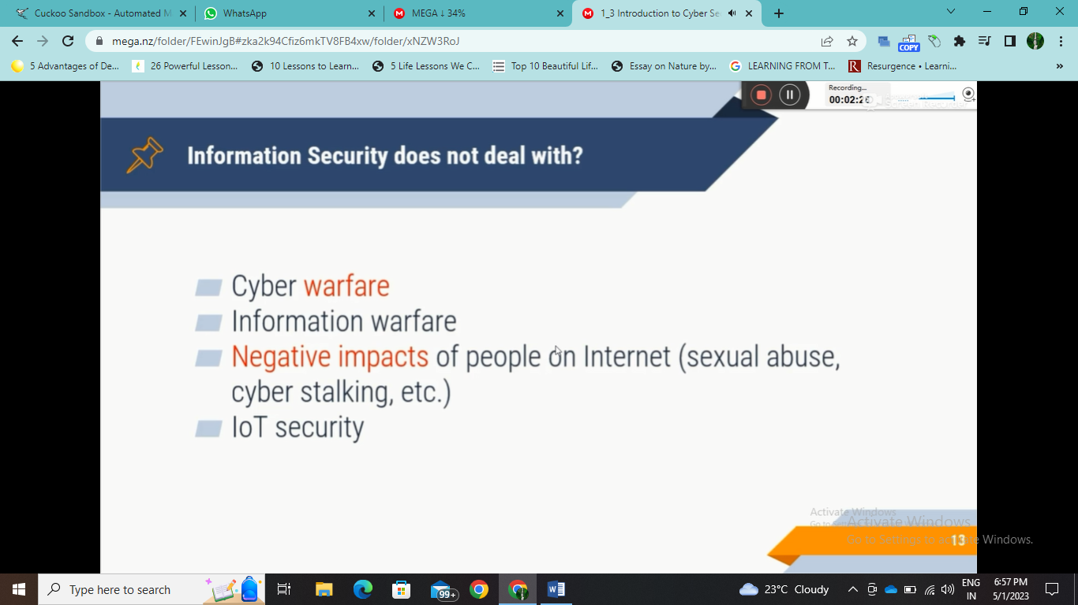

**Cyber warfare is an attack on another country through cyberspace that is digital like dos attack**

**Shutting down their government sites**

**Illegal things on the internet**

**IoT security**

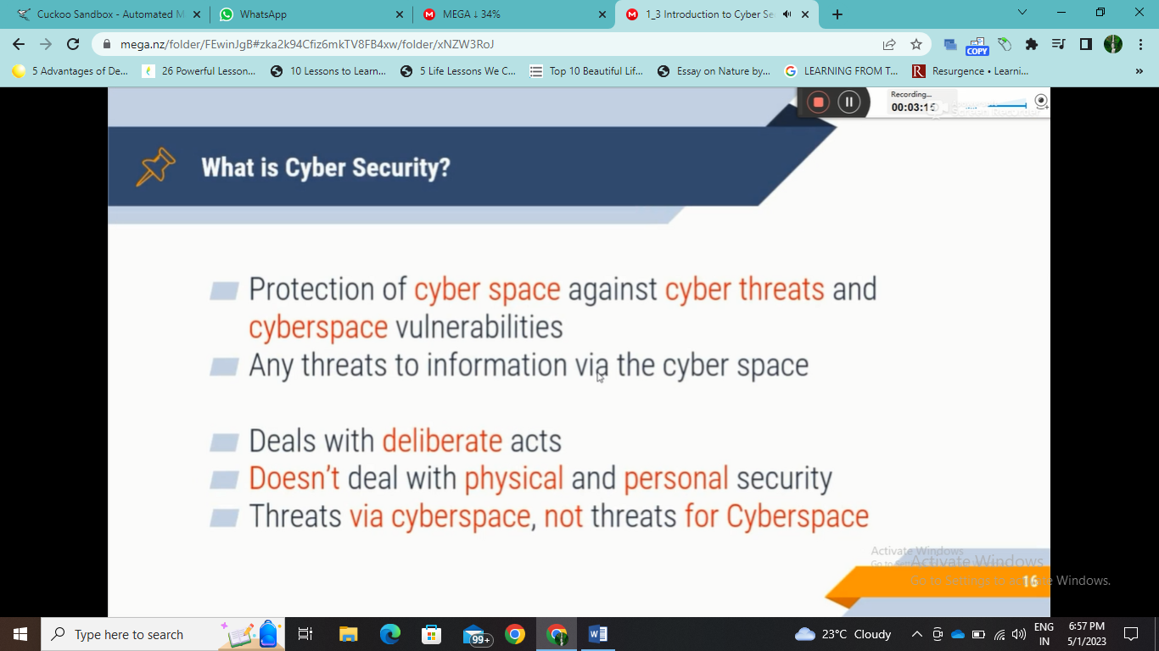

**All things on the internet are cyberspace all the connections routers and phones are cyberspace it is wide**

**So threats via cyberspace can be controlled by cyber security**

**Here you will use term confidentiality instead of privacy**

**Here info sec is not used as no physical data like papers in your cupboard are not in cyberspace**

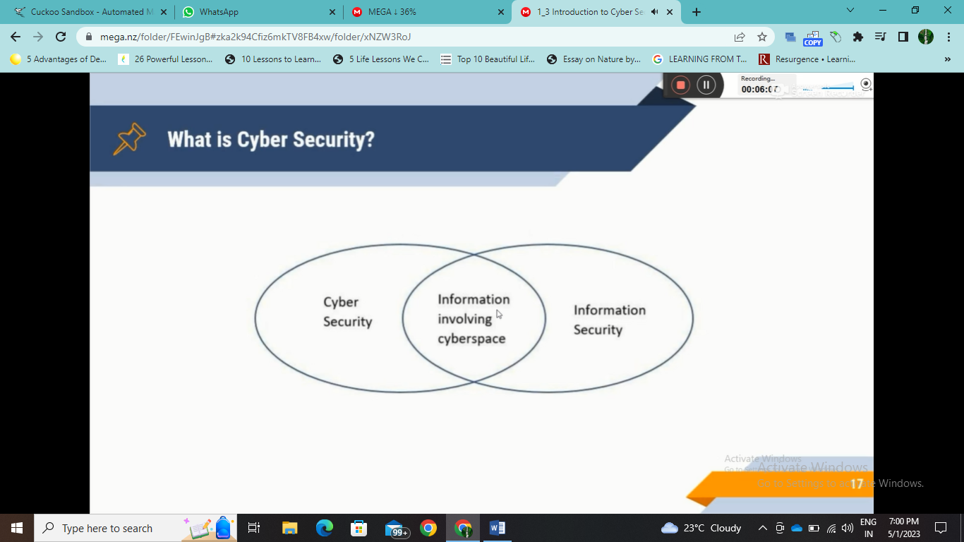

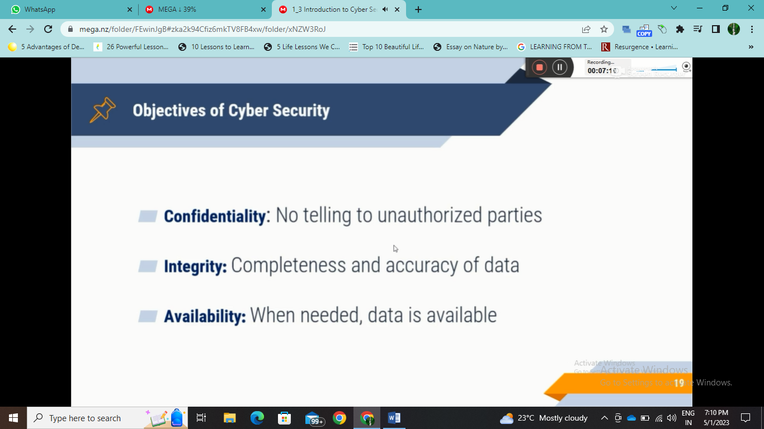

**Data ki properties hai ye**

**Confidentiality is that ki jo maine kaha vo desired user tak hi jaye no third party involved that no data breaching**

**Privacy is the personal data whereas confidentiality is for the organization or company’s large data no leakage of data to third parties**

**The integrity that is no change or modification in the data sent by the user**

**Availability of data as per user requirements**

**Privacy is respect to a single person and confidentiality is respect to an organization or company**

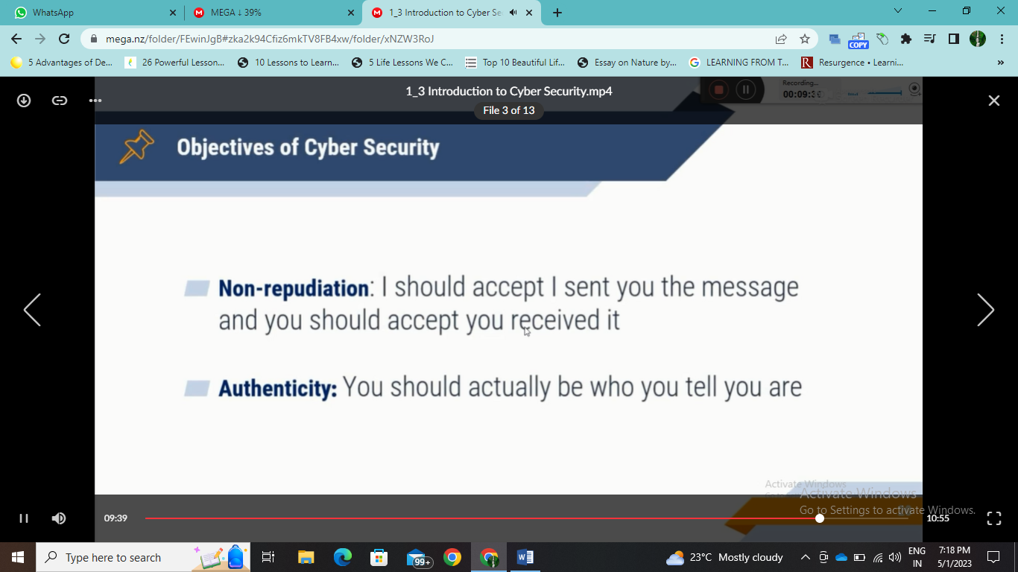

**That is there should be a system that after receiving the message or payment he should not deny. It.**

**Authenticity is that message should be sent by the right user that can be checked by username and password and the message should be delivered to the right person**

**The right sender and right receiver is authenticity**

**These were the 5 basic properties of data**